Lecturer’s name: N/A | Date: Day 4
Course: Math | Unit: Equivalent Forms of Fractions, Decimals, and Percents
Unit Duration: 10 days | Lesson Duration: 1 day
TEKS: 6.4E, 6.4F, 6.5B, 6.5C | Lesson Part 1
Topic: Converting Fractions and Decimals to Percentages

Lesson objectives:
1. SWBAT use benchmark percents on a percent bar to find the percent of a number.

Essential Questions:
What is benchmark percent?
How can I use benchmark percents to find the percent of a number?
What operations will be most important to use during this process?

LYS Methodology

Be (Character/Values/Principles) - Educational, Financial, Vocational, Spiritual - How can I utilize benchmark percentages as an example to find individuals in my life that can help me move to the next step?

Know (What resources are available to the student/ How can they use them) - Educational and Financial - Why is it important to learn about benchmark percentages and how can I use those techniques in our personal lives to achieve success however that may look like?

Do (Execute with Excellence) - Educational, Financial and Vocational - How can we use benchmark percentages to build resourcefulness, connectedness, and alignment?

Resources (Include Technology):
Instructional Input - Asynchronous
AS: Anticipatory Set (Introduction)
- Students warm up for today’s lesson is answering questions such as:
  - When you share a snickers with another friend you are dividing that snickers by ______
  - When you share a cake with 3 cousins, you are dividing that cake by ________
  - When you share a turkey with 9 other family members, you are dividing that turkey by _______
M: Modeling (I do)
- Introduce Key Point: I can use benchmark percents (50%, 25%, 10%, 1%) to find the percent of any number.
- Model Part 1: Teacher will model ONE problem
- 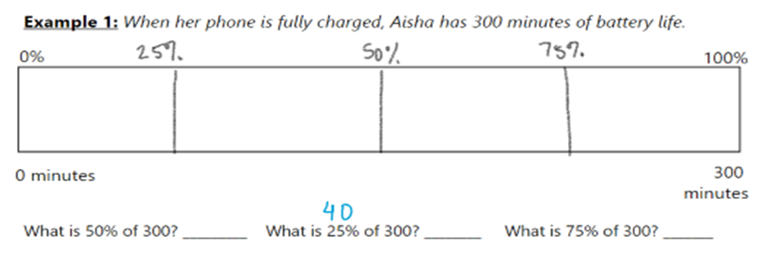
- Check for Understanding: Create a question similar to Example 1
- Criteria for Success:
  - To find 50%, I divide by two
  - To find 25%, I divide by four
  - To find 10%, I divide by 10

- Model Part 2: Model problem below. Highlight others ways to use some of these percents to find some of the missing values such as 10% + 20% = 30% so the value for 10% + the value for 20% will give you the value for 30%
- 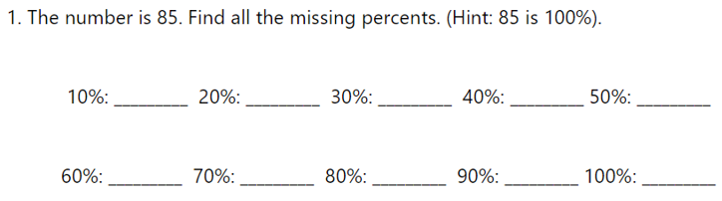
- Criteria for Success:
  - To find 50%, I divide by two
  - To find 25%, I divide by four
  - To find 10%, I divide by 10
GP: Guided Practice (We do)
- Create 3 additional problems such as model part 2
- Include an FDP (fraction, decimal, table) as an extension portion to spiral in previous lessons with an increase in rigor by adding decimals to percents and improper fractions such as 125/100

Instructional Input - Synchronous
AS: Anticipatory Set (Introduction)
- Students warm up for today’s lesson is answering questions such as:
  - When you share a snickers with another friend you are dividing that snickers by ______
  - When you share a cake with 3 cousins, you are dividing that cake by ________
  - When you share a turkey with 9 other family members, you are dividing that turkey by _______
M: Modeling (I do)
- Introduce Key Point: I can use benchmark percents (50%, 25%, 10%, 1%) to find the percent of any number.
- Model Part 1: Teacher will model ONE problem
- 
- Check for Understanding: Create a question similar to Example 1
- Criteria for Success:
  - To find 50%, I divide by two
  - To find 25%, I divide by four
  - To find 10%, I divide by 10

- Model Part 2: Model problem below. Highlight others ways to use some of these percents to find some of the missing values such as 10% + 20% = 30% so the value for 10% + the value for 20% will give you the value for 30%
- 
- Criteria for Success:
  - To find 50%, I divide by two
  - To find 25%, I divide by four
  - To find 10%, I divide by 10
GP: Guided Practice (We do)
- Create 3 additional problems such as model part 2
- Include an FDP (fraction, decimal, table) as an extension portion to spiral in previous lessons with an increase in rigor by adding decimals to percents and improper fractions such as 125/100

Independent Practice/ Homework
- Students complete online game comparing converting fractions, decimals and percents - Millionaire FDP Game

Lesson Close

Vocational
“Your network is your net worth” - Porter Gale

Working with benchmark percents also known as friendly percents is an example of how to find close and known individuals in your own network to move onto the next step. Before learning how to walk or run, everyone had to learn how to crawl. Similar to that, learning how to calculate the benchmark percents and then utilizing those values to achieve the rigorous ones is how life works. Use your small circle of people to expand your network of individuals you want to collaborate with, be mentored by or follow.

Finding benchmark percents not only guides individuals on the process behind the math but it allows an individual to learn how to be resourceful with certain values, how to connect patterns and how to align certain values before moving onto the next step. Each of these executions and characteristics must be followed to achieve success in whatever personal or professional goal an individual has.

